**Commodore PET/CBM 1541 Adapter Rev. 0**

Prototype Testing

# Test Setup

* Prototype Rev. 0 installed in the User Port
* CBM8032
* 2532 EPROM “VC-1541-DOS/80” in UD11
* Cassette Dongle with ribbon cable for power supply
* 1541 and 1541-II disk drives with different floppy disks and serial cable
* SD2IEC with a suitable disk image on SD-card
* Pi1541 with a suitable disk image on SD-card
* 1581 with a suitable disk
* A C64 setup with disk drive to check the files written with

# Test Execution

With each drive, the same tests were executed:

1. Showing the disk status with !@
2. Formatting the disk with !@”N:CBM8032,00
3. Showing the directory with !catalog
4. Saving a program with !save”<prog name>”
5. Verifying the program with !verify”<prog name>”
6. Loading a program with !load”<prog name>
7. Writing a SEQ file with the program “seqtest”
8. Reading the SEQ file

The sequence of the test steps are not necessarily the same. The program “seqtest” looks like this:

2 print"scratch file"  
5 !@"s:test"  
7 print"open test for writing  
10 !open#1,"test,s,w"  
20 fori=1to100  
30 !print#1,"This is a test"  
40 next  
50 !close#1

## General Results

All tests were executed successfully except reading back the sequential file with the CBM8032 on any drive. It turned out, that the file number for !open, !input# etc. is rather a secondary address. An !open#15,”test,s,r” returned a “syntax error” in the status and SA 15 is for sending commands to the disk drive. An !input#2,a$ always returned a “G” in a$ (note: the software was found in an old EPROM and scope of the project is to reconstruct the hardware).

The SEQ file from the CBM8032 was the read with a program on the C64.

50 INPUT"FILE NAME";N$  
70 OPEN2,8,2,N$+",S,R"  
80 INPUT#2,A$  
90 PRINTA$  
100 IF ST<>0 THEN120  
110 GOTO80  
120 CLOSE2

The result looks ok.

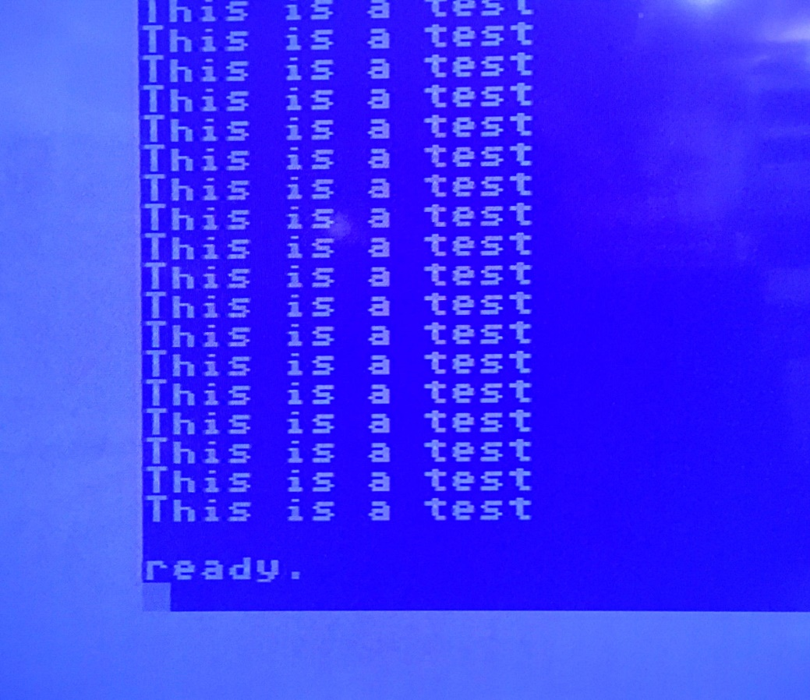

Figure 1: The SEQ file read with a C64

Further, the SD2IEC was not capable of the !catalog command. A !load”$” did work, though.

## Pictures of the tests

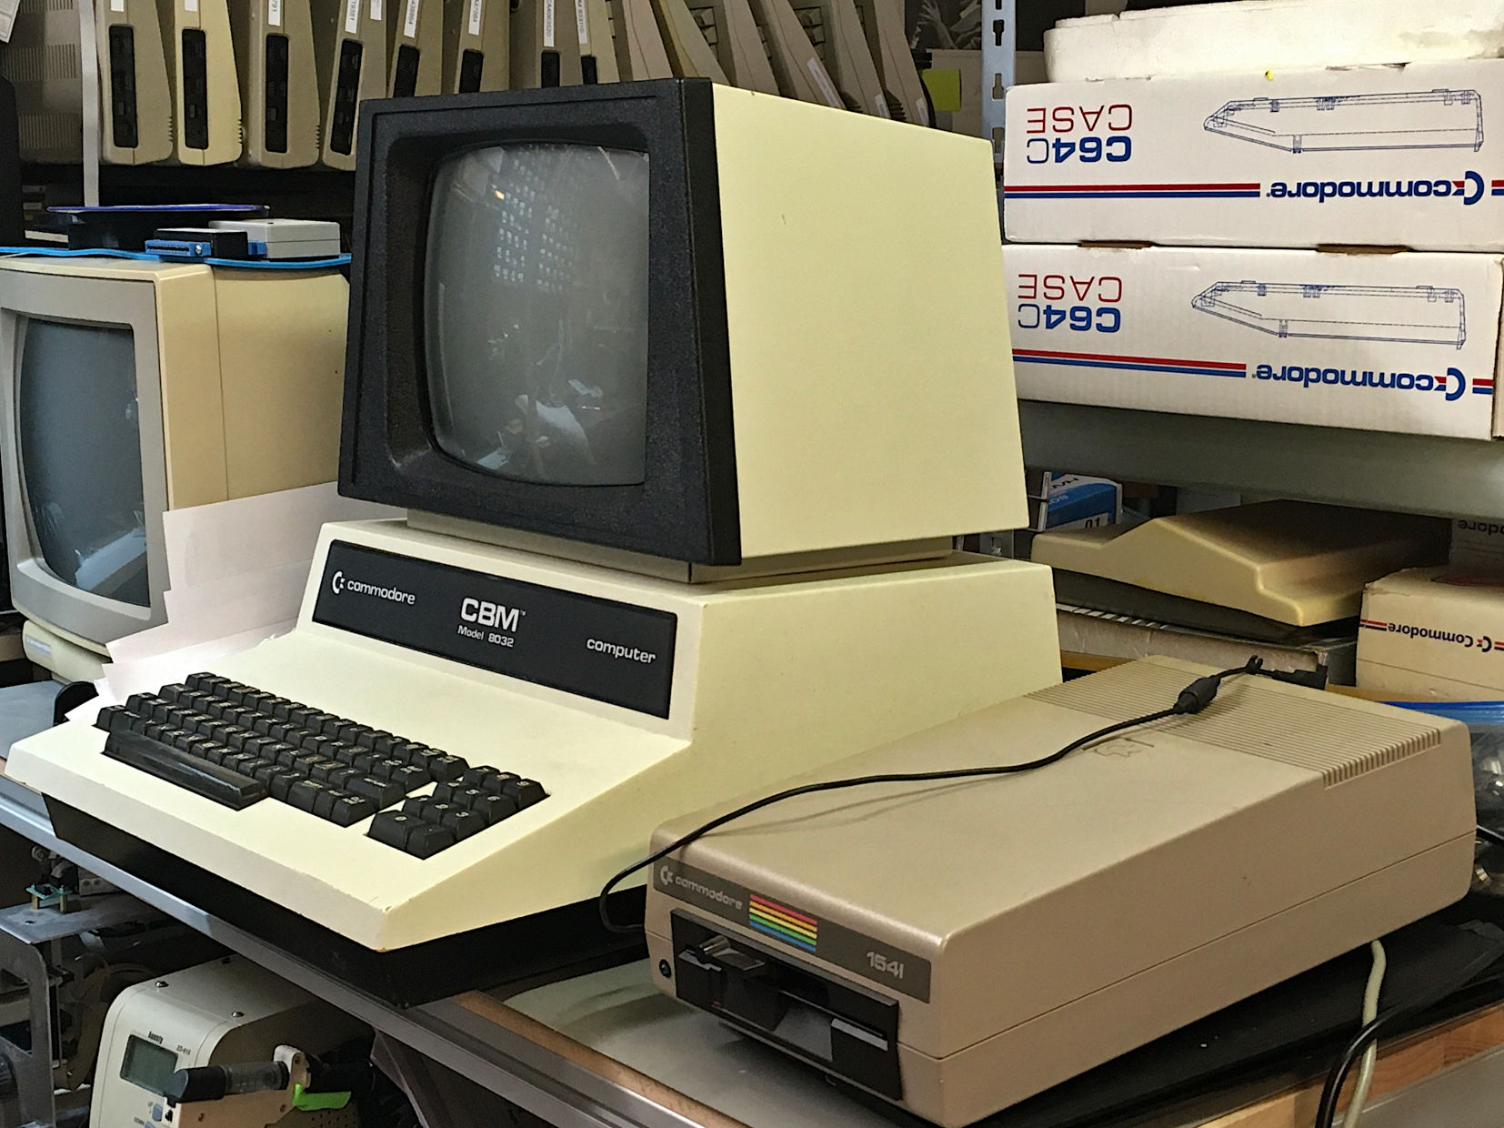

Figure : CBM8032 with a 1541 (SpeedDOS ROM)

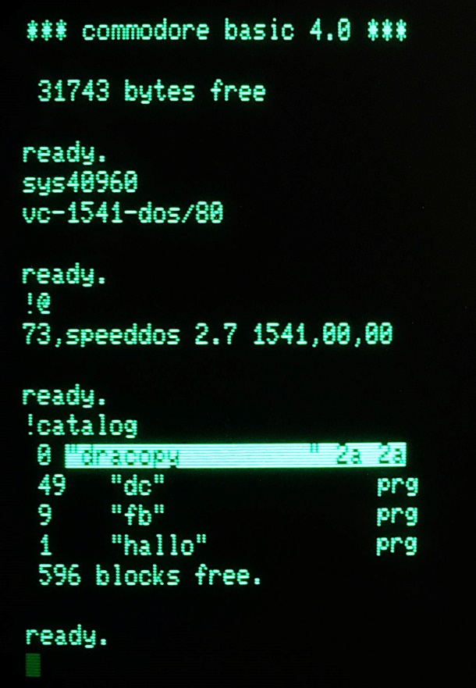

Figure 3: Software start, status and directory (1541)

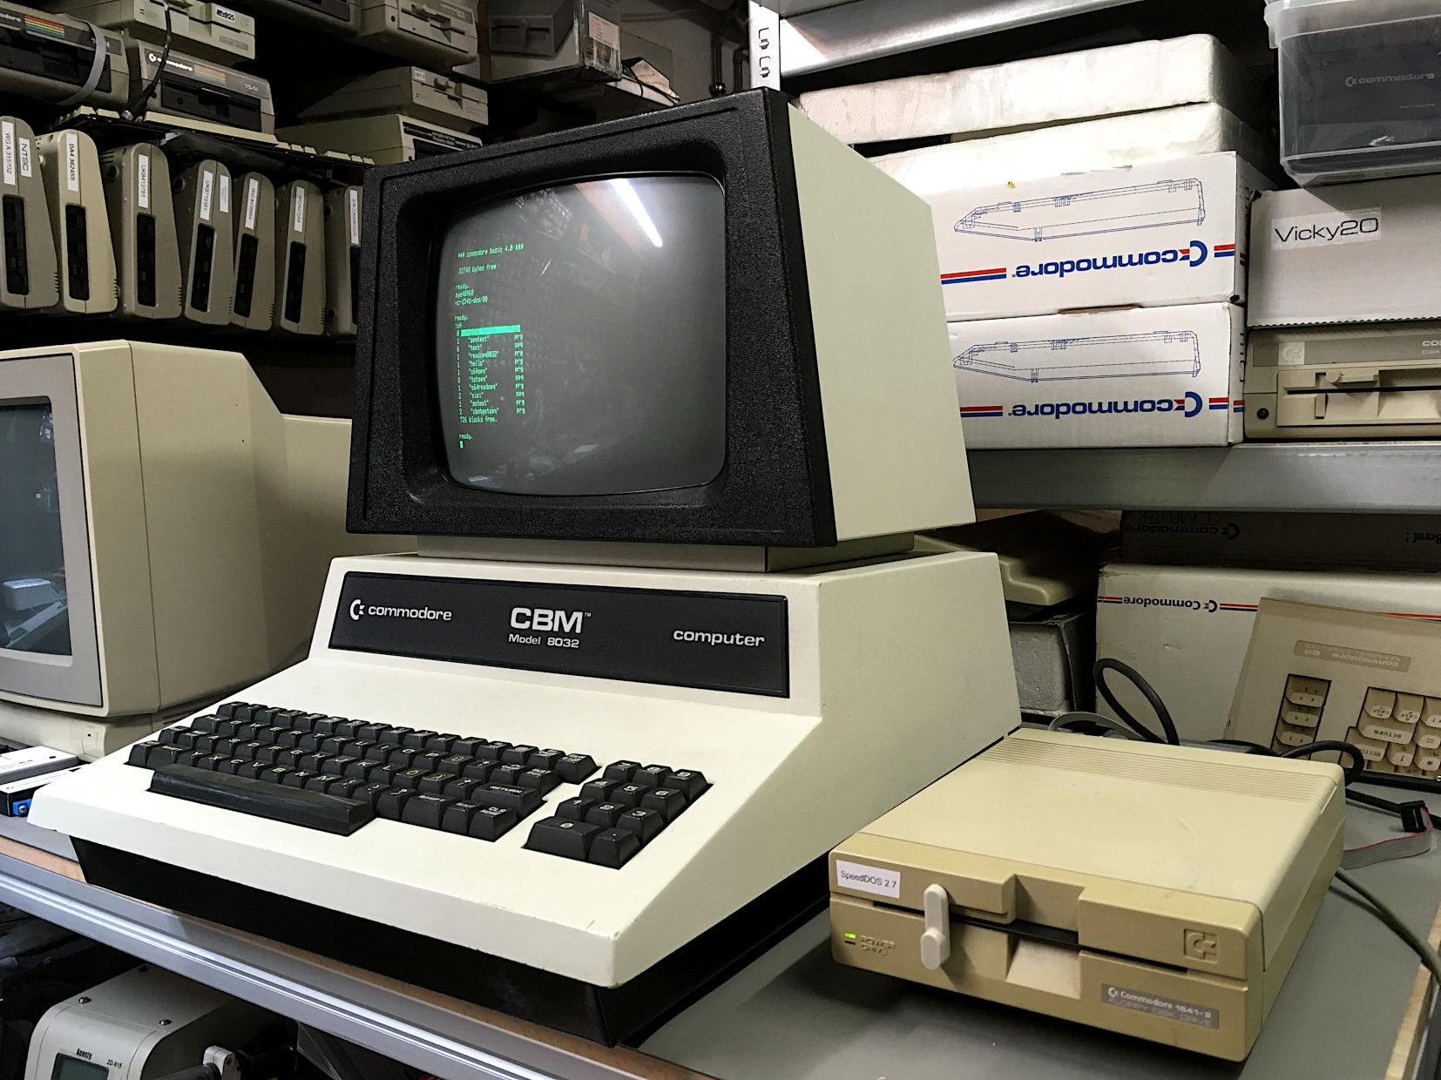

Figure 4: Setup with the 1541-II (SpeedDOS ROM)

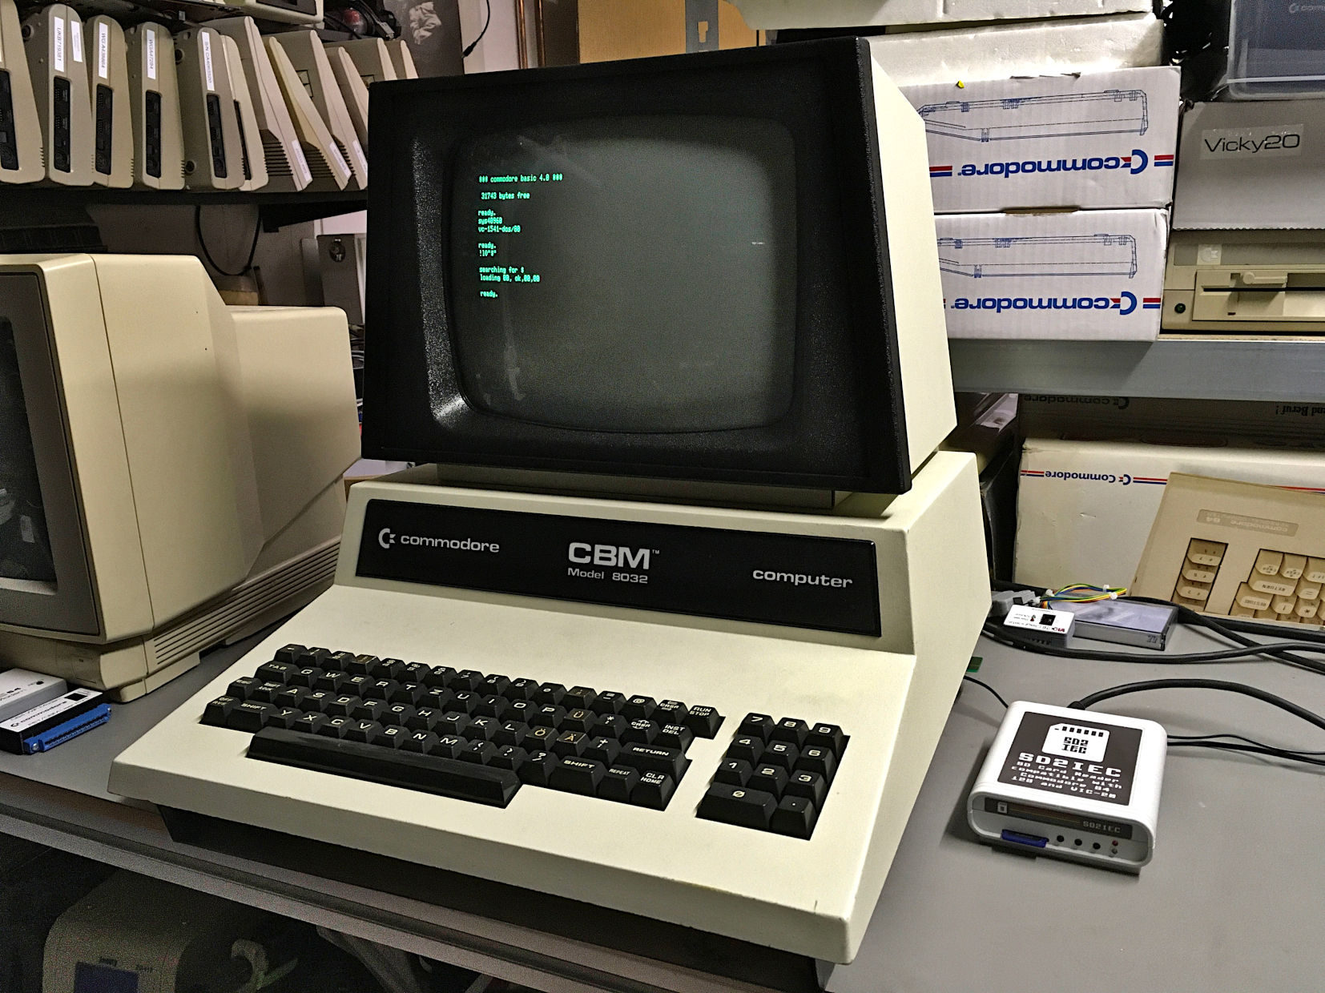

Figure 5: Setup with the SD2IEC

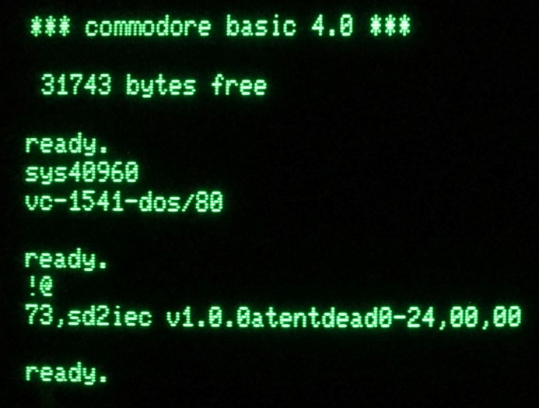

Figure 6: Software start and status (SD2IEC)

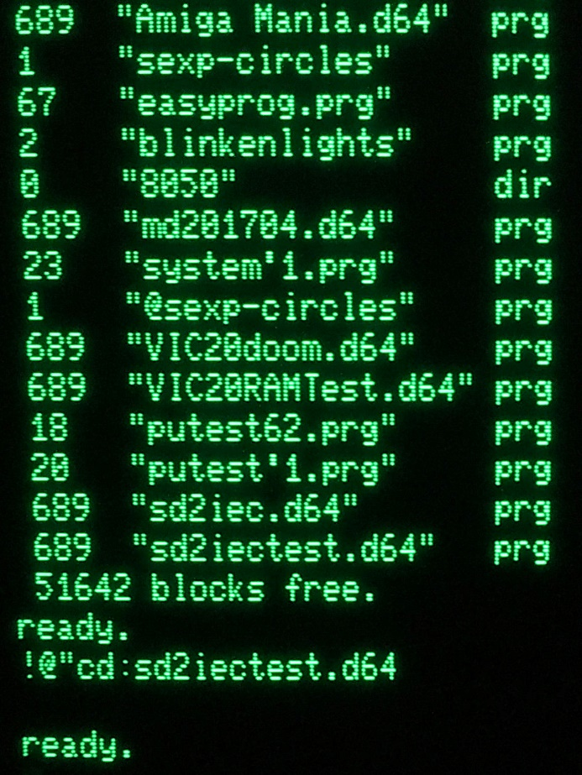

Figure 7: directory and change directory instruction (SD2IEC)

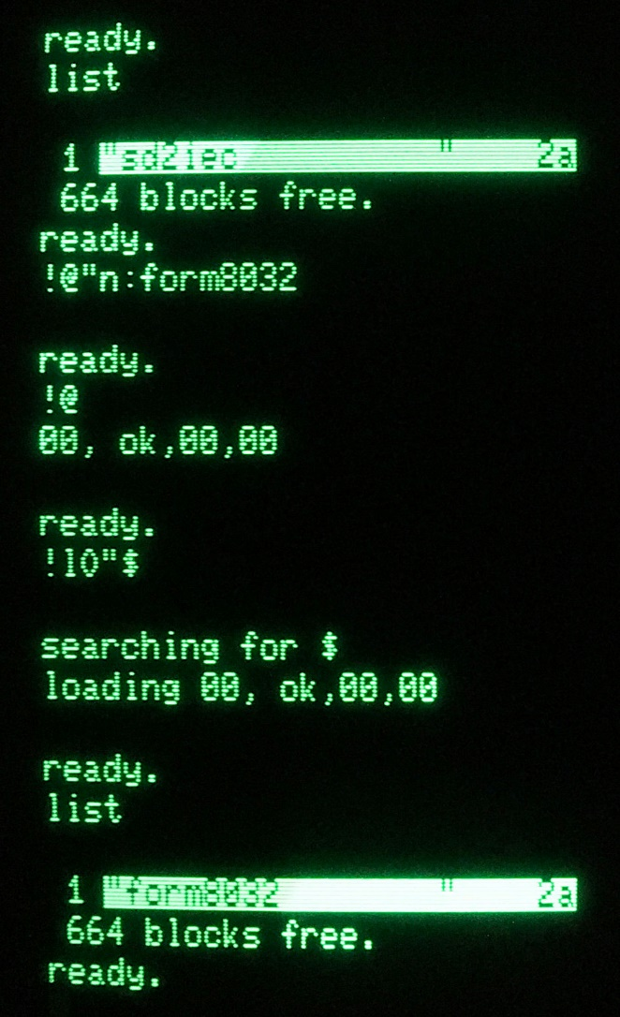

Figure 8: Formatting a disk image (SD2IEC)

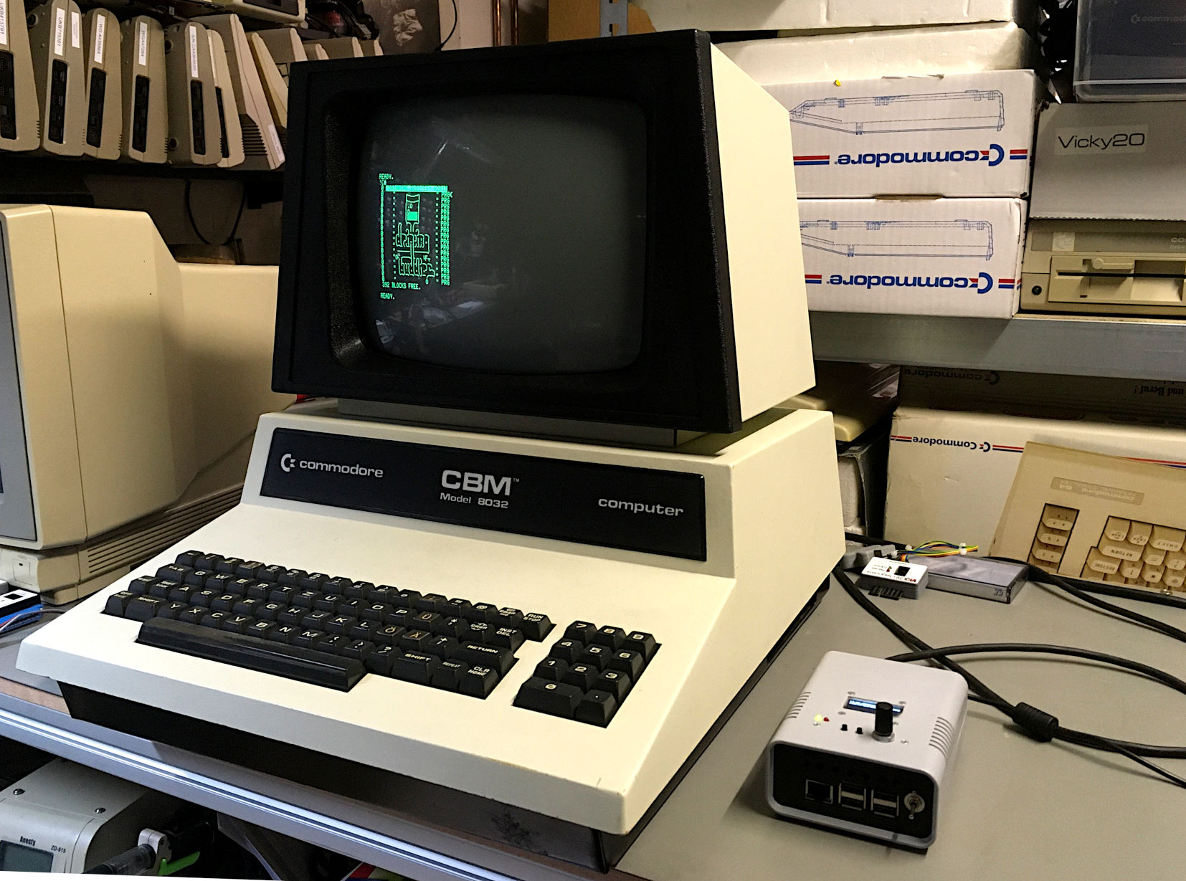

Figure 9: Setup with Pi1541

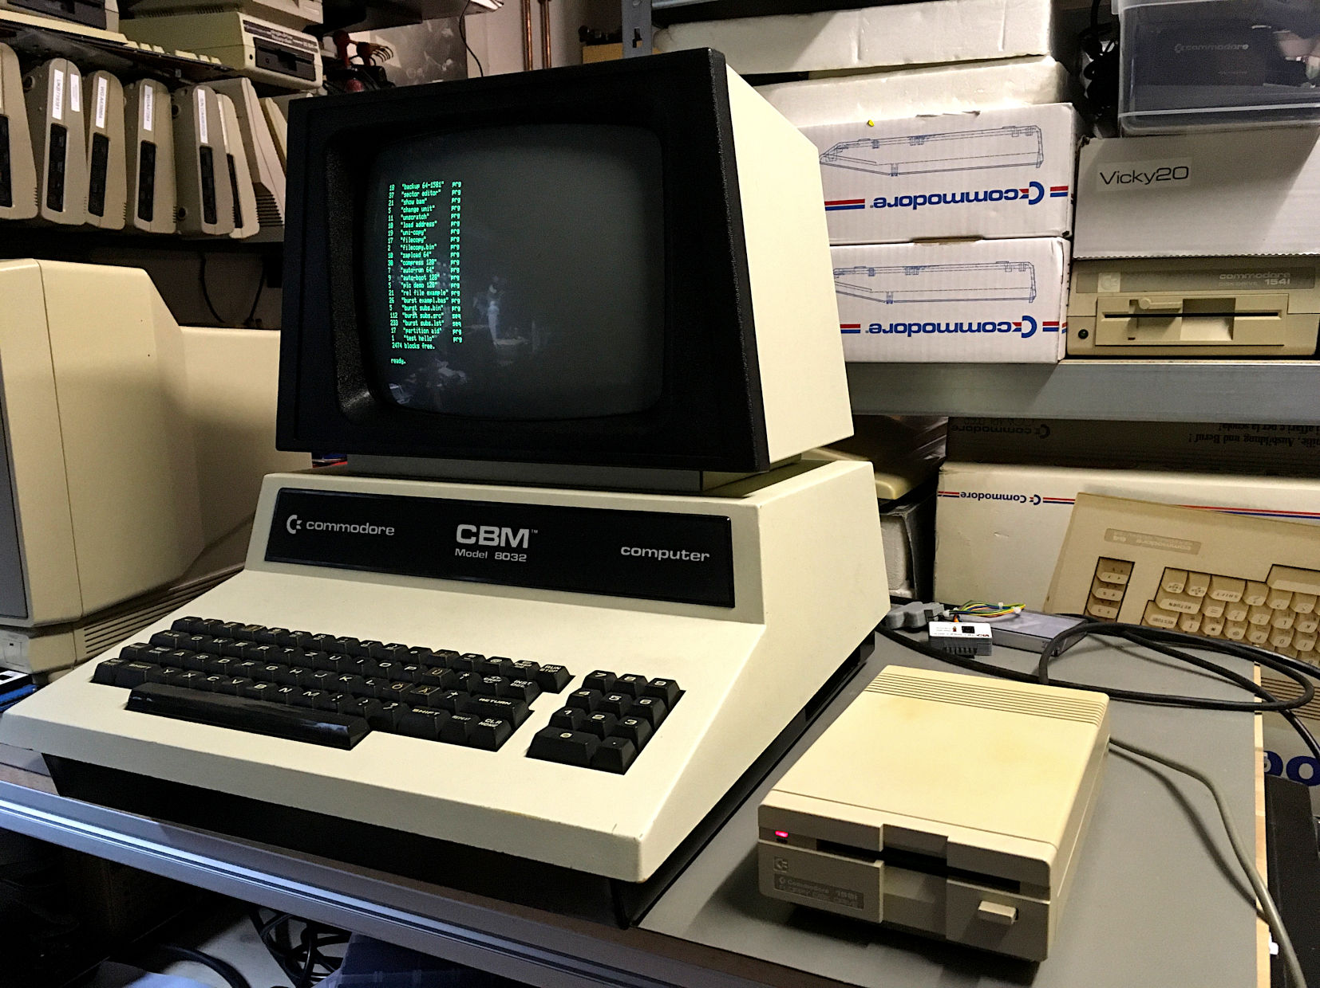

Figure 10: Setup with the 1581

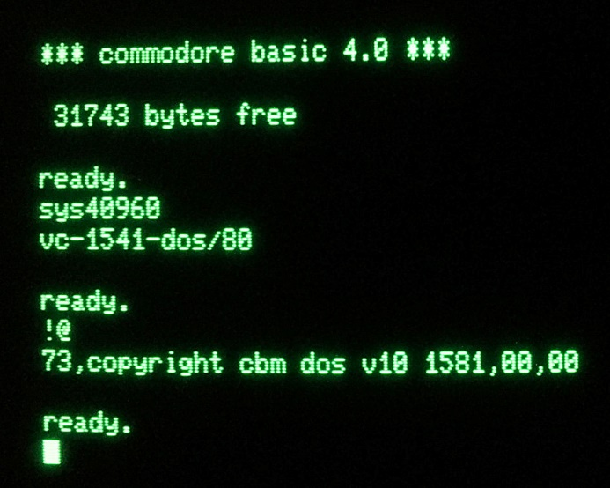

Figure 11: Software start and status (1581)

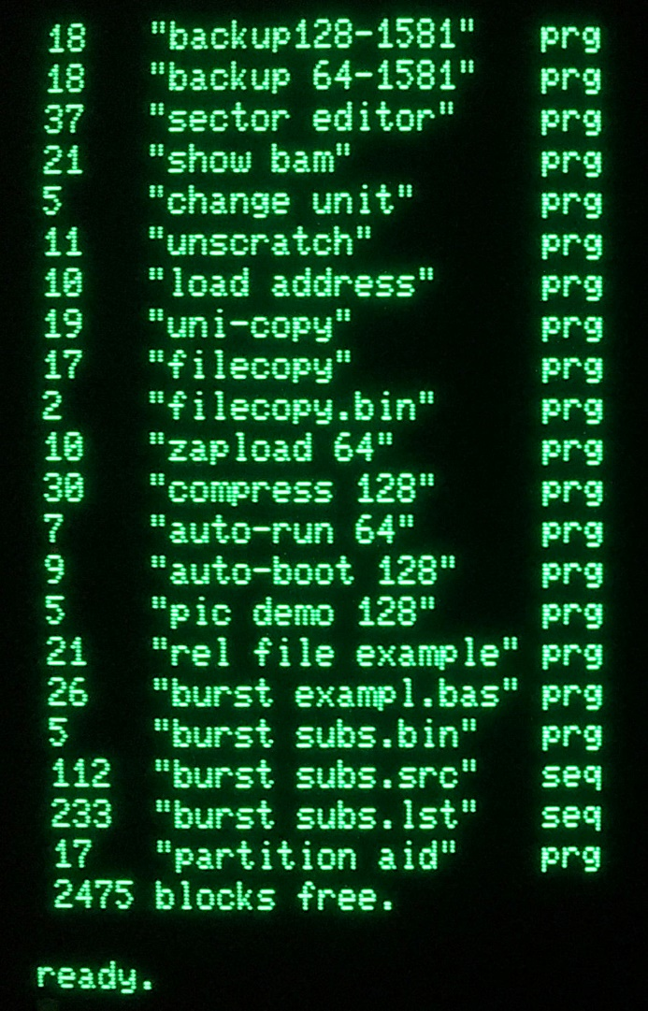

Figure 12: !catalog with the 1581

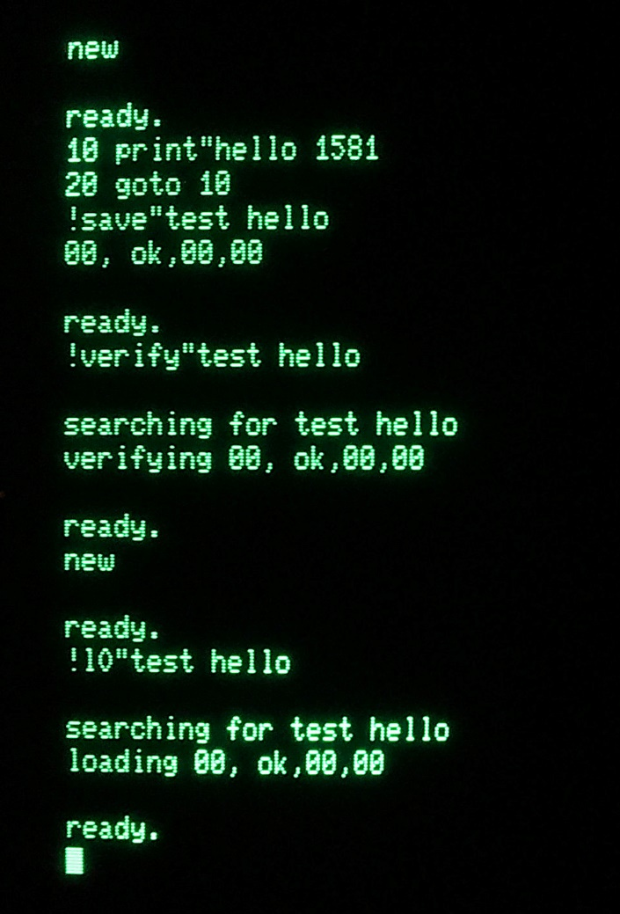

Figure 13: Test of the 1581 (!save, !verify, !load)

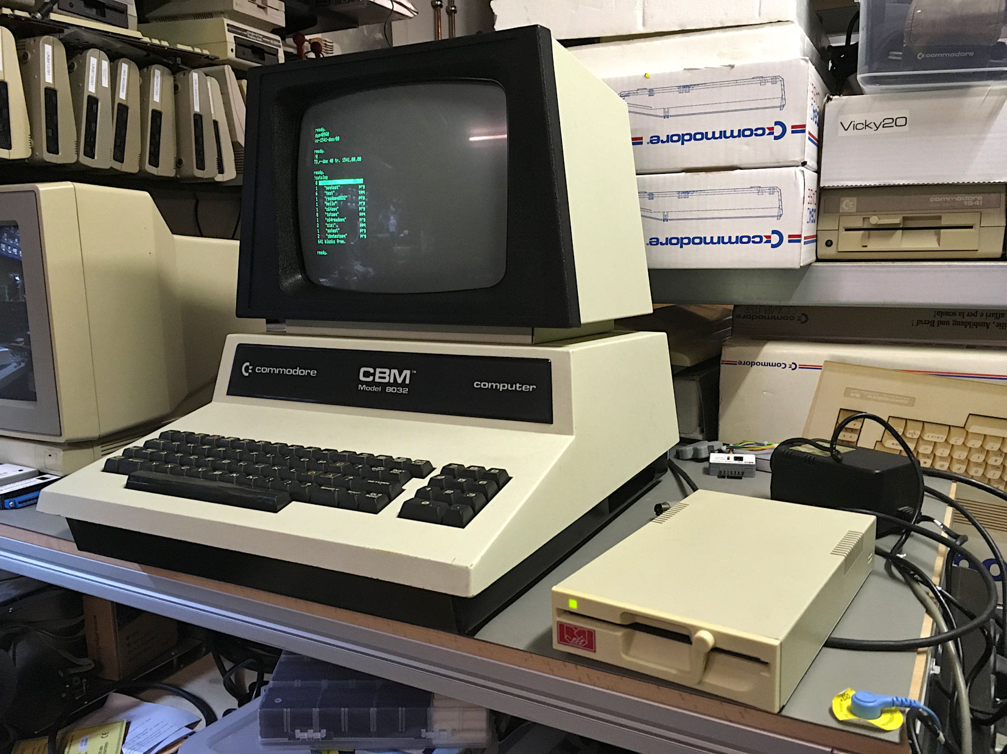

Figure 14: Setup with the Oceanic OC-118N

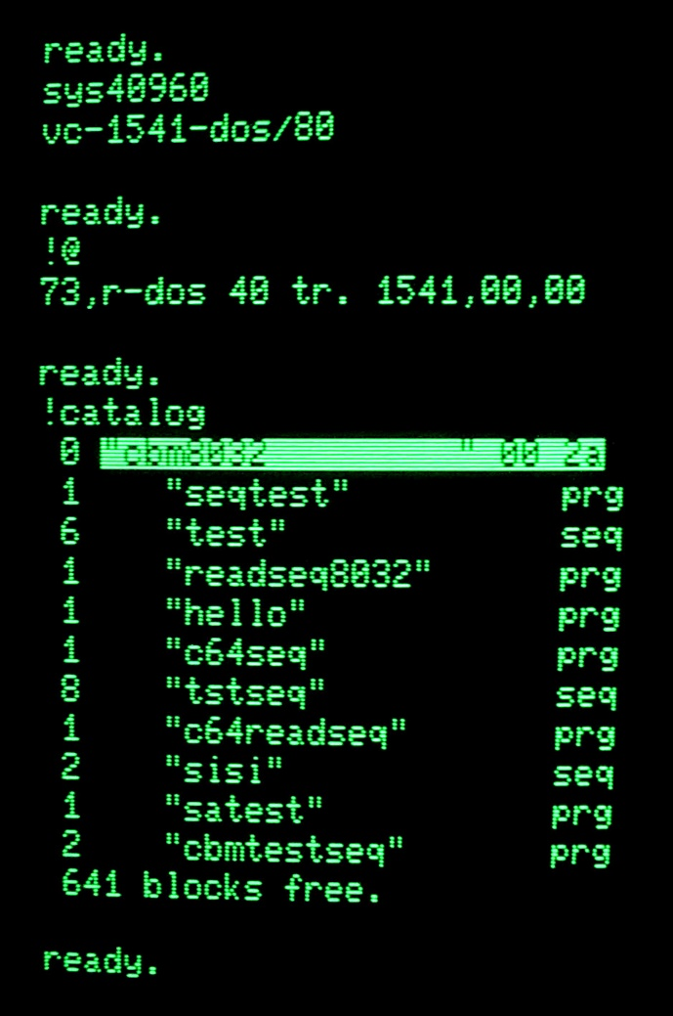

Figure 15: Status (OC-118N)

# Result

The hardware of the PET/CBM 1541 Adapter is fully functional. The software, that was found in the EPROM seems to work at least mostly. It is not sure, if the !input# and !get# instructions work properly, since the proper instruction syntax might not be figured out, yet.